Client-Server Architecture

Example of UML diagram in client-server architecture (chat application):
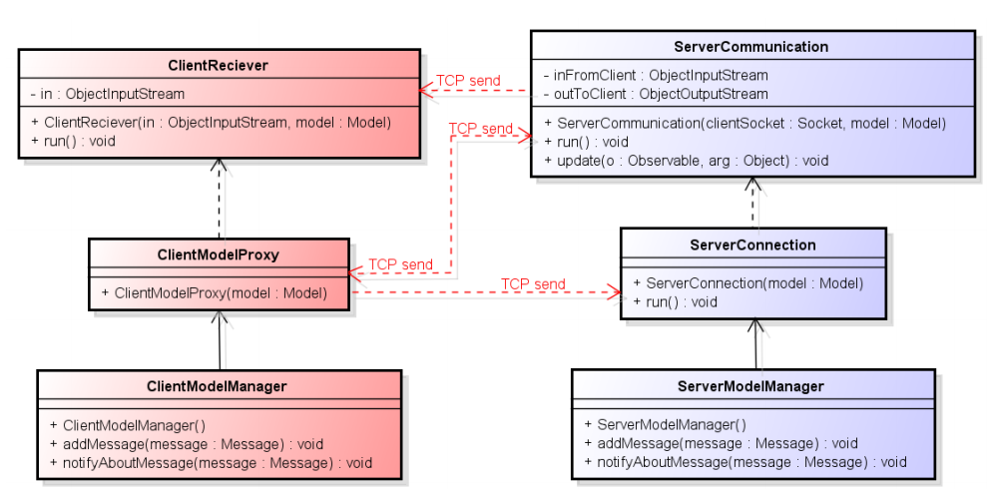

General description of Client-Server:
- Client-server architecture (client/server) is a network architecture in which each computer or process on the network is either a client or a server. Servers are powerful computers or processes dedicated to managing disk drives (file servers), printers (print servers), or network traffic (network servers ). Clients are PCs or workstations on which users run applications. Clients rely on servers for resources, such as files, devices, and even processing power.
Client-Server using Java sockets:
- Server:
  - On server side the port number needs to be specified. Following is to create welcome socked. “ServerSocket welcomeSocket = new ServerSocket(PORT);”. Welcome socket is used to “welcome” clients who try to connect to the server. When the client connects to the server, the connection controller is created “Socket connectionSocket = welcomeSocket.accept();”. Connection controller is used to create ObjectStreams. Those send and receive objects from client.
  - // create output stream attached to the socket ObjectOutputStream outToClient = new ObjectOutputStream( connectionSocket.getOutputStream());
  - // create input stream attached to the socket ObjectInputStream inFromClient = new ObjectInputStream( (connectionSocket.getInputStream()));
  - Reading an sending objects from clients is done by writeObject() and readObject methods from ObjectStreams.
- Client:
  - Client is done in similar way. To create connection it needs to know port number used on server and servers IP address. “Socket clientSocket = new Socket(HOST, PORT);”. After the client socket is created, ObjectStreams are created in similiar way as in server, only using clientSocket.
Client-Server according to UML diagram:
- Class server connection is responsible for starting the server and waiting for the clients to connect. After the client connects to the server, the instance of serverCommunication class is created with connectionSocket.
- Class serverCommunication is responsible for creating object streams and communication with client.
- Class clientModelProxy is responsible for connecting to the server and creating clientReceiver.
- Class clientReceiver is receiving objects from server and passing them to the client system.

Our implementation of Client-Server:
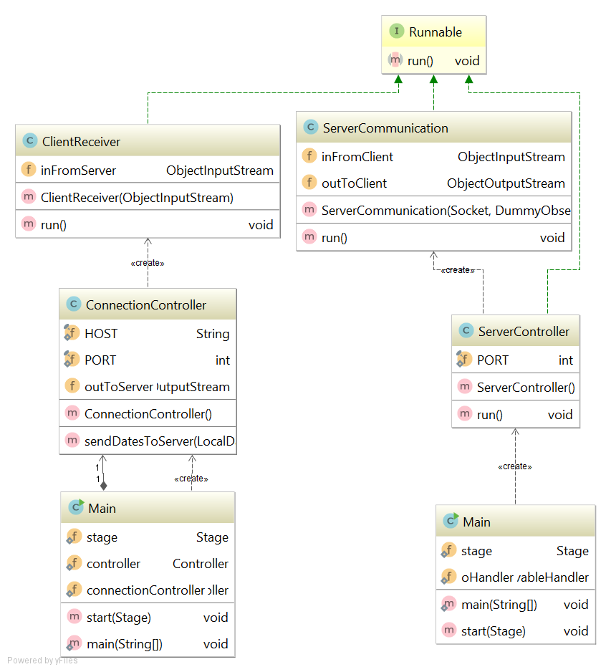

Description of our implementation:
- Server:
  - After the main class creates serverController the welcome socket is created and sever controller waits for clients to connect.
  - When client connects, serverCommunication is created. After that the current trip list is sent to the client and then the class waits for dates from client side which are then passed to the different part of the system to be handled.
  - Other parts of the system responsible for sending objects to clients are DataHandler and DummyObserver.
- Client:
  - The connection controller connects to the server and creates object streams and client receiver.
  - Client receiver is expecting ProxyTripList object from list. When it is received, the list is displayed in client GUI.
Code examples:
- Class ServerController
public class ServerController implements Runnable {
private static final int PORT = 6666;
public void run() {
int count = 1;
try {
ServerSocket welcomeSocket = new ServerSocket(PORT);
System.out.println("Server started");
DummyObserver observer = new DummyObserver();
while (true) {
Socket connectionSocket = welcomeSocket.accept();
ServerCommunication c = new ServerCommunication(connectionSocket, observer);
new Thread(c, "Communication " + count).start();
count++;
}
} catch (Exception e) {
e.printStackTrace();
}
}
}

- Run method from class ServerCommunication.

- public void run() {
try {
outToClient.writeObject(DataHandler.getInstance().getTrips());
outToClient.reset();
} catch (IOException e) {
e.printStackTrace();
}
while (true) {
try {
LocalDate[] dates = (LocalDate[]) inFromClient.readObject();
DataHandler.getInstance().getInDates(dates, outToClient);
inFromClient.reset();
} catch (IOException e) {
//
} catch (ClassNotFoundException e) {
//
}
}
}

- Contructor of ConnectionController

public ConnectionController() throws IOException {
try {
Socket socket = new Socket(HOST, PORT);
outToServer = new ObjectOutputStream(socket.getOutputStream());
ObjectInputStream inFromServer = new ObjectInputStream(socket.getInputStream());
ClientReceiver reciever = new ClientReceiver(inFromServer);
new Thread(reciever, "Reciever").start();
} catch (Exception e) {
e.printStackTrace();
}
}

- Run method from ClientReceiver
- @Override
public void run() {
while (true) {
try {
ProxyTripList trips = (ProxyTripList) inFromServer.readObject();
Main.controller.showList(trips);
} catch (IOException | ClassNotFoundException e) {
e.printStackTrace();
}
}
}

